**Functional Requirements Document (FRD) (v1.1)**

**1. Introduction**

**1.1 Purpose**

This document details the functional requirements for the athlete management and event monitoring system. It outlines how the system will support event management, user profile management, event registration, coaching requests, and news publication.

**1.2 Scope**

The system includes features for managing events, profiles, registrations, coaching requests, and news.

**1.3 Audience**

* Project stakeholders
* Development team
* Quality assurance team
* System administrators

**2. Functional Requirements**

**2.1 Event Management**

**Create Event**

* **Description**: Allow users to create events.
* **Inputs**: Event name, description, photo URL, date, venue.
* **Outputs**: Confirmation of event creation.

**Update Event**

* **Description**: Enable updates to event details.
* **Inputs**: Event ID, updated details.
* **Outputs**: Confirmation of event update.

**Get Event Details**

* **Description**: Retrieve detailed information about a specific event.
* **Inputs**: Event ID.
* **Outputs**: Event details.

**List Upcoming Events**

* **Description**: List all events scheduled for the future.
* **Inputs**: None.
* **Outputs**: List of upcoming events.

**List Past Events**

* **Description**: List all events that have already occurred.
* **Inputs**: None.
* **Outputs**: List of past events.

**Add Event Item**

* **Description**: Add items to an event.
* **Inputs**: Event ID, item details.
* **Outputs**: Confirmation of item addition.

**Get Event Registrations**

* **Description**: Retrieve registrations for a specific event.
* **Inputs**: Event ID.
* **Outputs**: List of registrations.

**Record Performance**

* **Description**: Record athlete performances in specific event items.
* **Inputs**: Event item ID, athlete ID, performance details.
* **Outputs**: Confirmation of performance record.

**Get Event Results**

* **Description**: Retrieve results for all items in a specific event.
* **Inputs**: Event ID.
* **Outputs**: Event results.

**2.2 User Profile Management**

**Create Athlete Profile**

* **Description**: Allow users to create athlete profiles.
* **Inputs**: Personal details, photo.
* **Outputs**: Confirmation of profile creation.

**Create Coach Profile**

* **Description**: Allow users to create coach profiles.
* **Inputs**: Personal details, achievements, photo.
* **Outputs**: Confirmation of profile creation.

**Update Athlete Profile**

* **Description**: Enable updates to athlete profiles.
* **Inputs**: Athlete ID, updated details.
* **Outputs**: Confirmation of profile update.

**Update Coach Profile**

* **Description**: Enable updates to coach profiles.
* **Inputs**: Coach ID, updated details.
* **Outputs**: Confirmation of profile update.

**Get Athlete Profile**

* **Description**: Retrieve details of a specific athlete profile.
* **Inputs**: Athlete ID.
* **Outputs**: Athlete profile details.

**Get Coach Profile**

* **Description**: Retrieve details of a specific coach profile.
* **Inputs**: Coach ID.
* **Outputs**: Coach profile details.

**List All Athletes**

* **Description**: List all registered athletes.
* **Inputs**: None.
* **Outputs**: List of athletes.

**List All Coaches**

* **Description**: List all registered coaches.
* **Inputs**: None.
* **Outputs**: List of coaches.

**List Coaches Accepting Requests**

* **Description**: List coaches who are open to receiving coaching requests.
* **Inputs**: None.
* **Outputs**: List of coaches accepting requests.

**Toggle Accepting Requests**

* **Description**: Allow coaches to toggle their availability for accepting new requests.
* **Inputs**: Coach ID, availability status.
* **Outputs**: Confirmation of status update.

**2.3 Event Registration**

**Register for Event**

* **Description**: Allow athletes to register for events.
* **Inputs**: Athlete ID, event ID.
* **Outputs**: Confirmation of registration.

**Approve Event Registration**

* **Description**: Admin can approve event registrations.
* **Inputs**: Registration ID.
* **Outputs**: Confirmation of registration approval.

**Reject Event Registration**

* **Description**: Admin can reject event registrations.
* **Inputs**: Registration ID.
* **Outputs**: Confirmation of registration rejection.

**Get Athlete Registrations**

* **Description**: Retrieve registrations made by a specific athlete.
* **Inputs**: Athlete ID.
* **Outputs**: List of athlete registrations.

**2.4 Coaching Requests**

**Send Coaching Request**

* **Description**: Allow athletes to send coaching requests to coaches.
* **Inputs**: Athlete ID, Coach ID, request details.
* **Outputs**: Confirmation of request sent.

**Respond to Coaching Request**

* **Description**: Coaches can accept or reject coaching requests.
* **Inputs**: Request ID, response status.
* **Outputs**: Confirmation of response.

**Get Coach Athletes**

* **Description**: Retrieve the list of athletes associated with a specific coach.
* **Inputs**: Coach ID.
* **Outputs**: List of athletes.

**Create Coaching Relationship**

* **Description**: Establish a coaching relationship when a request is accepted.
* **Inputs**: Request ID.
* **Outputs**: Confirmation of coaching relationship creation.

**2.5 News**

**Publish News**

* **Description**: Allow the publication of news related to events, athletes, and coaching.
* **Inputs**: News details.
* **Outputs**: Confirmation of news publication.

**View News**

* **Description**: Public users, athletes, coaches, and admins can view news.
* **Inputs**: None.
* **Outputs**: List of news.

**3. Diagrams**

**3.1 Use Case Diagram**

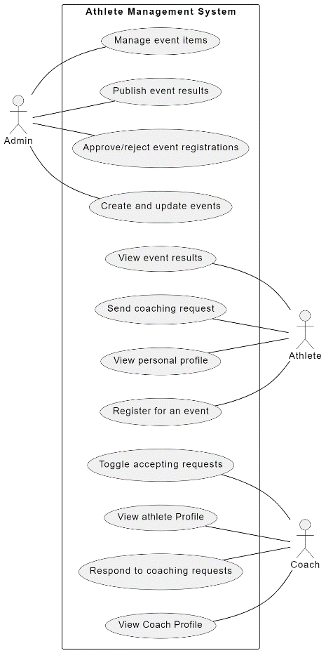

**3.2 Entity-Relationship Diagram (ERD)**

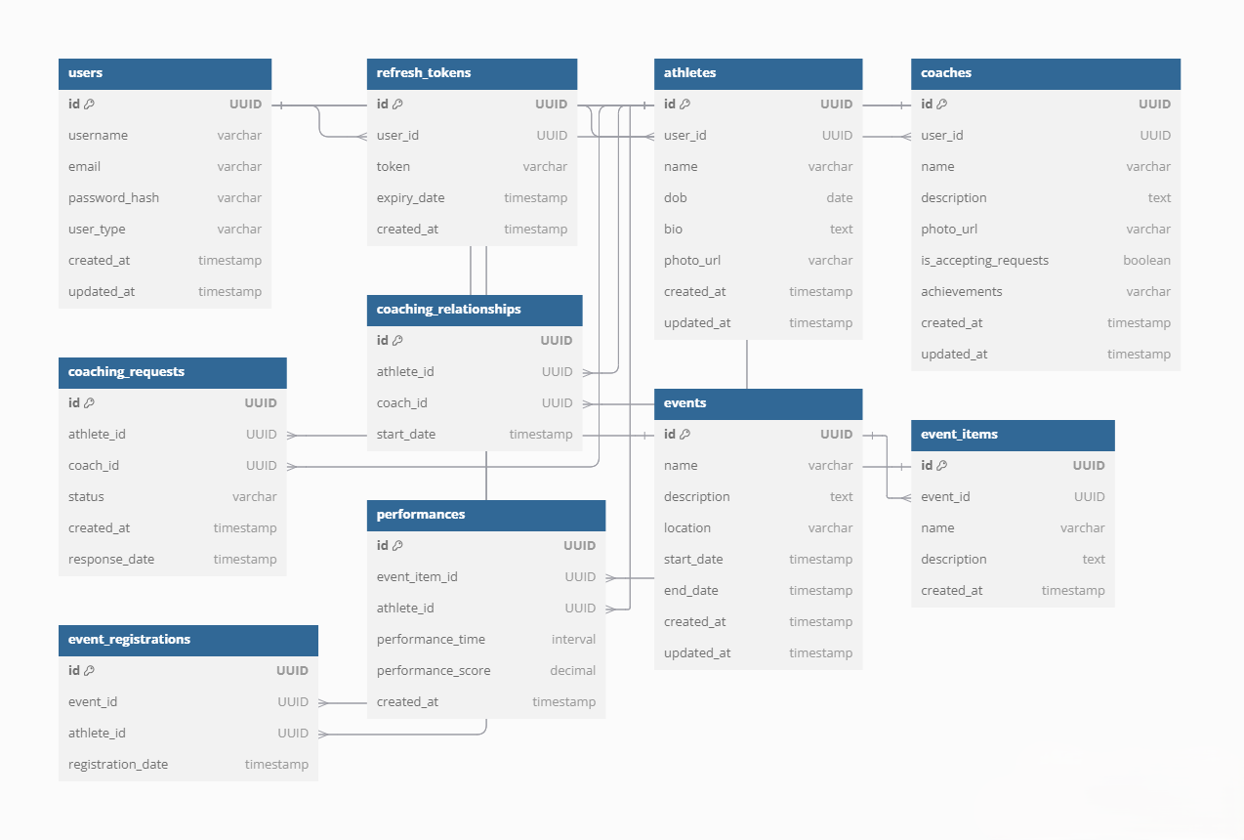

**3.3 Class Diagram**

**3.4 Sequence Diagram**

**3.5 Architecture Diagram**

**4. Conclusion**

This document outlines the functional requirements for the athlete management and event monitoring system. It serves as a basis for design and implementation to ensure that the system meets business needs.